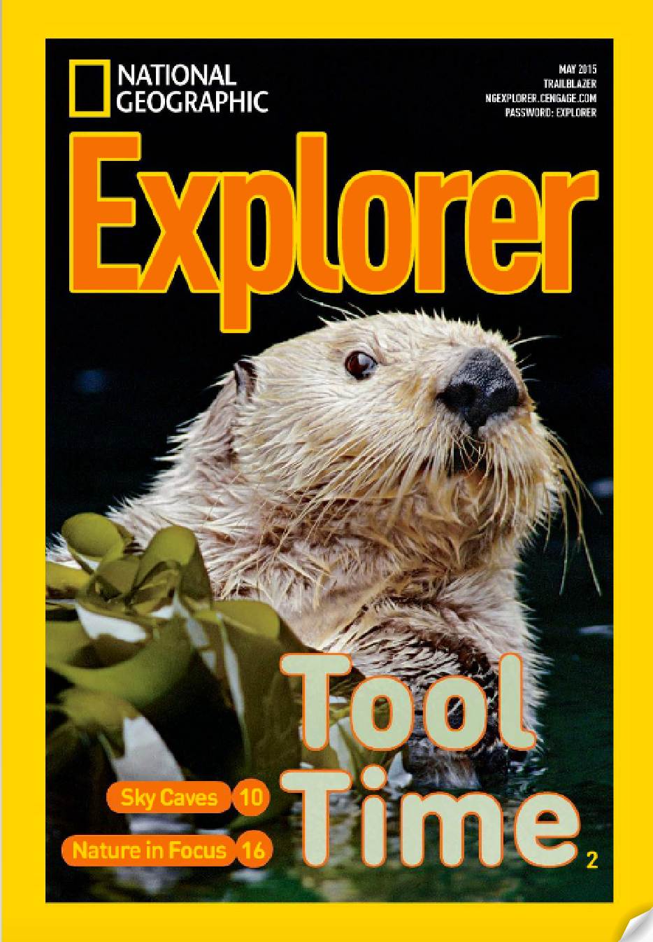

EDC 423

Informational Text Plan

For this assignment you will create a plan to discuss an informational text, based on the ideas presented in class and the thinking you did to create your plan for Pandamania!

To begin
Choose either “See How Cheetahs Survive In The Wild” or “Swim with Seahorses” from a National Geographic Explorer magazine, Pioneer Edition. These are expository/ informational texts appropriate for students in grades 2-3.

Part 1: Ideas and Learning Goals

- Read the text.

- Outline the main ideas and related details of the text.

- Identify some important concepts or “big ideas” that students can learn from reading and talking about this text. The big ideas might be related to content areas (science, civics, etc.) or to text (how texts are organized, how writers find out the information, etc.).

- Use your outline of #1 and 2 above (main and big ideas) to create learning goals for your discussion. What should your students know/learn from reading this text? You should frame you learning goals as questions (e.g. “How are caves formed?”). For each learning goal, list information students need to understand in order to reach that goal.

Part 2: Text Analysis

- Read the text again, carefully noting features/ideas that challenge comprehension, and those that support comprehension. Be sure to consider text features we discussed in class, such as:

Macro Features | Micro Features | Other issues of cohesion/coherence
- Genre  - Photos, diagrams, charts, maps  - Captions  - Type face (bold, italics)  - Glossary/TOC  - Headings  - Subheadings | - Transitions  - Referents  - Connectives | - Inferences needed  - Topic sentences  - Ideas fully explained/not explained  - Background knowledge unknown  - Organization (are ideas logically ordered?)

Note your analysis either by annotating a PDF (preferable) or annotating the text itself.

Part 3: Planning the Text Introduction/Launch

Consider how you will launch your topics and discussion. Script (that means write out what you will say) your launch, considering the points we discussed in class about the purpose and length of a launch.

Part 4: Assessing Learning Goals and Standards

- Consider how you might assess student learning of the important ideas in the text. How will you know if students have met the learning goals that you set? What will they do after the discussion to demonstrate learning?
- Which CCSS for Informational Text do your discussion and assessment meet? Note, since your text is appropriate to grades 2-3, you may choose either 2nd or 3rd grade CCSS.

Part 5: Supporting students in building mental representations of text

Think about the goals you created in Part 1, the information students need to understand and reach the goals (Parts 1 and 2), and the supports/challenges to students in creating mental representations of the text.

- Based on factors in #1 above, decide where in the text to stop to discuss the text with students. At each stopping point, consider the question you will ask to help students build knowledge toward the goals. When creating your questions, use information on kinds of questions and Chapter 7 of your text. Your questions should be open, to allow students to discuss.

- Create a chart (like the ones in the Caves and Panda examples) where you write the page number and your questions.

For example:

Page/ending phrase | Question
P. 19, 4th para, “she just keeps eating” | Q: So what did we learn about the panda?  A: Waterproof fur  Q: Why?  A: keeps her dry  Q: How does that connect to what we were talking about before about how animals make sure they survive?  A: Waterproof fur is an adaptation to where she lives

You must include:
  - Initial question (What you will ask first after you stop)
  - Concept or expected response (a general sense of what you want students to answer)
  - Follow-up question (What you will ask after the student has answered)
  - Concept or expected response (What you want students to answer)

Part 6: Self-Check

- Go back through your text analysis in Part 2. Highlight each feature you addressed in your questions. In other words, which of the things you identified as challenging did you actually talk about with students?

- Go back to your exit (Part 4, assessment). Address how your discussion (part 5) has helped students meet the learning goals.

Part 7. Write a short reflection
What did you learn from this assignment regarding discussing complex texts with students?

Submitting the Plan (SEE TEMPLATE AFTER THE SCORING RUBRIC)

Submit your plan via email:

Part 1, ideas/learning goals

Part 2, text analysis (either a PDF with comments embedded or hard copy)
- Parts 3, intro/launch
- Part 4, exit
- Part 5, discussion stopping points/questions (a table with page numbers and questions)
- Part 6, self-check on your challenges and learning goals (PDF, and narrative)
- Part 7, written reflection

EDC423 Informational Text Plan

50 Possible Points

 | Possible Points | Earned Points
Part 1
- Text outline captures the main ideas of the text and the supporting details needed to understand the main ideas.
- “Big ideas” identify the overarching messages/ideas that students can transfer to other aspects of life. | 8
- Learning goals identify the important content students need to deeply understand the text. | 4
- Learning goals include relevant text ideas necessary to understand/meet that goal | 2
Part 2  - Text analysis captures relevant text supports/resources | 5
- Text analysis captures relevant text confusions/challenges
- Text analysis captures other text ideas/issues that might make the text less cohesive/coherent (e.g. inferences, lack of clarity, organization)
Part 3  - Text introduction/launch engages students in thinking about the text ideas | 5
- Text introduction/launch sets purpose for reading/discussing the text
- Text introduction/launch anticipates one or more learning goals
Part 4  - Assessment identifies appropriate means of determining whether students met learning goals. | 5
- Relevant CCSS for informational text (2nd of 3rd grade) are included and appropriate
Part 5  - Stopping points within the text correspond to places that will help students build meaning from text to reach learning goals. | 5
- Initial queries are phrased to encourage students to summarize, explain, and interpret OR, if closed, are followed up by questions requiring explanation | 5
- Initial queries support students in building representations of ideas you identified as challenging | 3
- Expected responses to each query are included and are appropriate | 3
- Follow up queries clarify initial questions and promote critical thinking.  Part 6  - Self check is complete and thoughtful for connection between Parts 2 (text analysis) & 5 (discussion questions)  - Self-check appropriately analyzes connection between Parts 4 (assessment) & 5 (discussion questions) | 3
Part 7
- Flipgrid response is thoughtful and reflective
Submission  - Plan uses Standard English mechanics and grammar throughout | 2
- Plan is submitted on Blendspace as specified
TOTAL | 50

